Humanoid Robotic Arm

Guide-Prof.Purnachandra

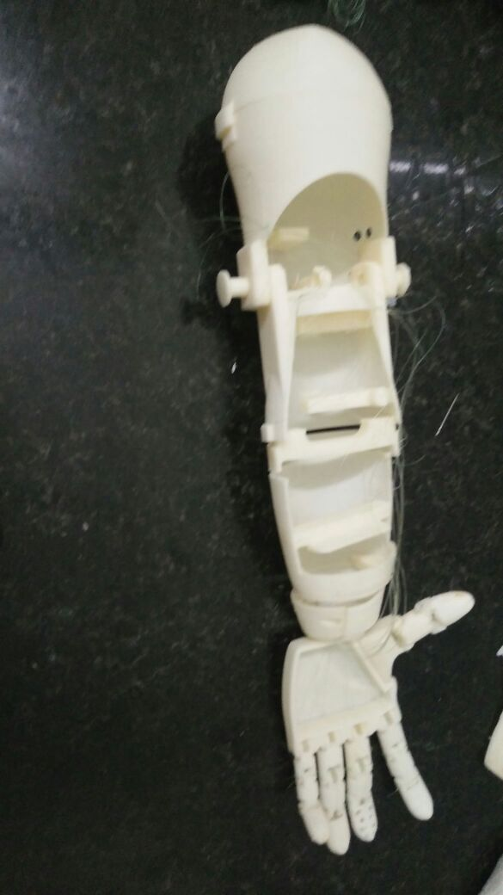

Members-

1. Tathagat Banerjee-17BCE7100
2. Ambika Prasad Swain-17BCN7025
3. Ashita Satpathy-17BEC7039
4. Akash Deep Dutta-17BME7035
5. Priyanka Mohanty-17BES7013

Statement of student contribution

* We independently carried out background research, design, and manufacturing to complete our Humanoid Robotic Arm.
* Starting from scratch, we designed and manufactured myoelectric prosthetic arm using computer modelling software and 3D printing fascilities provided by the mechanical workshop.
* Using our knowledge on mechanics, electronic and programming, we produced several functional prototypes with design inprovements.

**Introduction**

It could be argued that the most valuable possession to any human being is their body. Replacing a missing human limb, especially a hand, is a challenging task which makes one truly appreciate the complexity of the human body. For centuries innovators have been trying to replace lost limbs with manmade devices. Several prosthetic devices have been discovered from ancient civilisations around the world demonstrating the ongoing progress of prosthetic technology.

Until recent times the design of prosthetic limbs has progressed relatively slowly. Early innovations such as the wooden leg can be thought of as simple prosthetic devices. History shows that for a long time prostheses have remained passive devices that offer little in terms of control and movement.

Over time materials improved and designs started incorporating hinges and pulley systems. This led to simple mechanical body powered devices such as metal hooks which can open and close as a user bends their elbow for example.

Recent times however have given way to enormous advancements in prosthetic devices. Focus is not only on the physical aspects of a device but also the control and biofeedback systems. Slowly we are approaching an advanced trans-human integration between machine and body. Perhaps sometime in the future prosthetic devices will be faster, stronger and maybe even healthier than our biological limbs.

Throughout the course of this thesis we explored myoelectric prosthetic arms. It is aimed to design a device which mimics the function of the human arm as best as possible and can be controlled to some extent by muscular contractions.

**Problems**

To produce a functional prosthetic arm there are numerous design and manufacturing challenges to overcome. The challenge in this thesis is to create an arm of reasonable complexity and quality which can be further used for research in the field of prosthetics. It is important for the reader to note that this work encompasses several different engineering fields. Appropriate discussion will be allocated to each field and we shall aim to tie together all areas into a single, robust, functional system. Below are the major areas that were addressed throughout this thesis.

**Physical Design** The complexity of the mechanical and electrical systems determine how well the device mimics the human arm and the amount of dexterity it is able to offer. The design will aim to be as physically advanced as possible.

**Control Scheme** Ideally we would like a prosthesis to be as easy and natural to control as possible. If the user is straining to complete the most basic of tasks, such as grasping an object, then the prosthesis is most likely not beneficial in any practical sense.

**Practicality** The device must aim to be useful to an amputee. Whether or not this device is ever actually used by an amputee in uncertain, however the goal is to develop a prosthesis which has the ability to benefit people with missing hands.

**Affordable** We shall aim to keep the material cost of the device as low as possible. Modern commercial myoelectric prosthetic arms generally cost about Rs20 000 - Rs40 000. The material cost for this design will be under Rs500. Each of these challenges specifically the physical design and control system will be discussed thoroughly throughout this thesis.

**Objective**

Throughout the entirety of this thesis it has been approached as a full time endeavour. Manufacturing, assembly and testing was undertaken in the college during the day..

A 3D printable design for a myoelectric prosthetic arm is presented. The arm is electronically actuated and controlled by a user flexing his/her muscles. The bionic arm presented has the potential to be used by an amputee or person born without a limb. This type of technology does exist although it is expensive and generally not available to people in developing countries.

Rapid growth and advancement of the 3D printing industry allows individuals to become small scale manufacturers. Recent advancements show 3D printed prosthetic arms being attached to victims of war throughout North Africa. Such devices are purely mechanical and significantly less complex than myoelectric devices. Nevertheless, we can see that 3D printed devices have the potential to positively impact people’s lives. 3D printing does have its limitations but growth and development in the field will only lead to improvements over time.

This thesis topic covers a broad range of engineering disciplines. The root of the system is an innovative mechanical design for a 3D printed prosthetic arm. Modern day electronic actuators and circuitry animate the device and allow for sophisticated control schemes. It is hoped that this work will be of value to a diverse audience.

**METHODOLOGY**

* **Mechanical Design-**

To create a useful myoelectric prosthesis it is necessary to have a well-designed mechanical system which mimics the functionality of the human arm as best as possible. Among many other things mechanical design involves how joints are actuated and the types of forces present in the system. The bionic arm design presented in this section can be entirely manufactured with a 3D printer and basic tools.

* **Electrical Design--**

**Signal Flow Overview**

A user flexing generates an analogue signal which is amplified, rectified and smoothed byt he EMG sensor board. The microcontroller uses this analogue signal to generate a pulse width modulated signal. This drives servo motors which tension the tendons causing the

fingers to curl up.

As previously discussed the actuators used in this system are standard servo motors. These motors can be controlled to rotate to angular positions up to ± 90 degrees from rest. Since the artificial tendons move fairly little in order to open and close each finger, the angular precision of each servo somewhat affects how precisely the fingers can be controlled. Relatively inexpensive servo motors have been used in this system to maintain a low cost. The use of higher quality servos would of course increase finger strength and precision but would cost significantly more.

**Circuit Design-**

The following schematic outlines the circuitry of the system. Note that six power regulatorsare incorporated but only one has been shown for clarity.



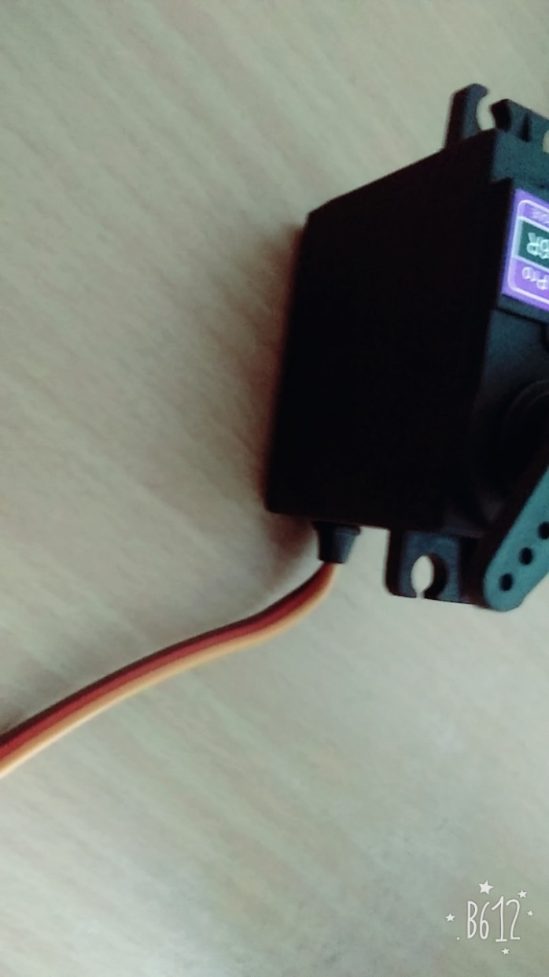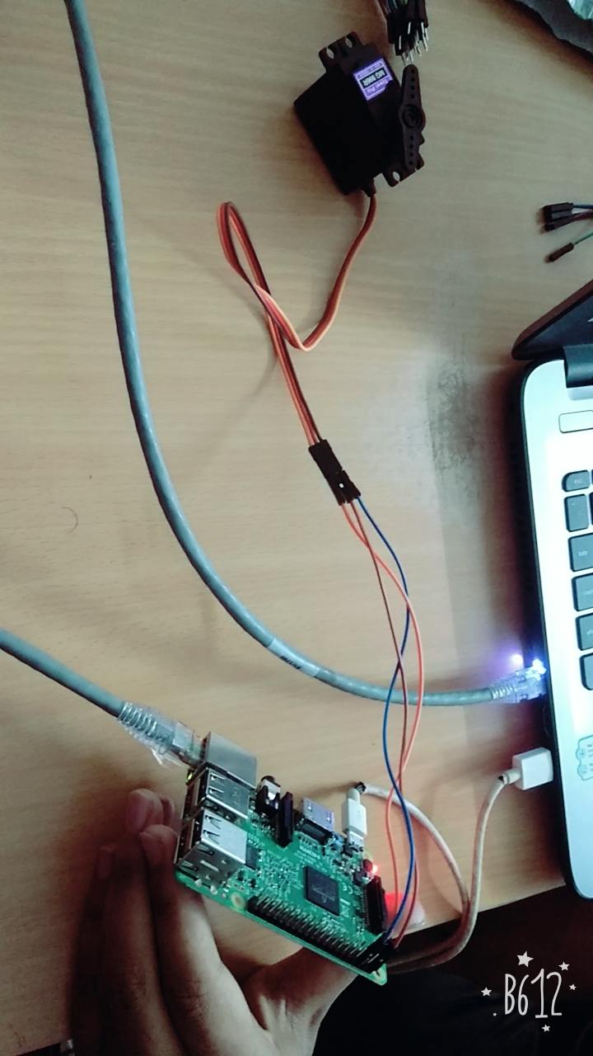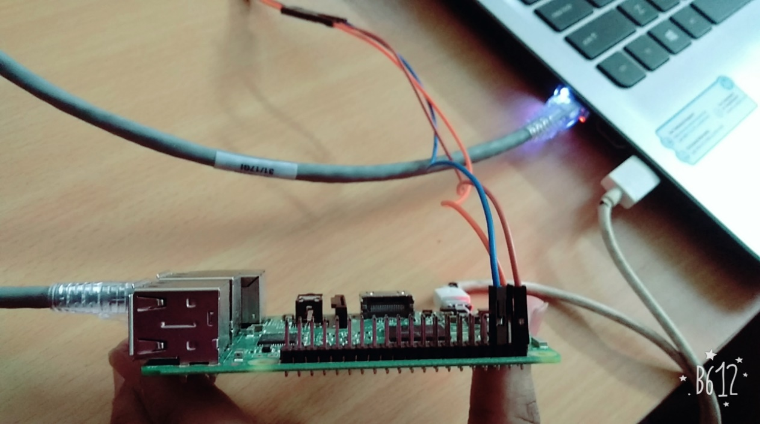

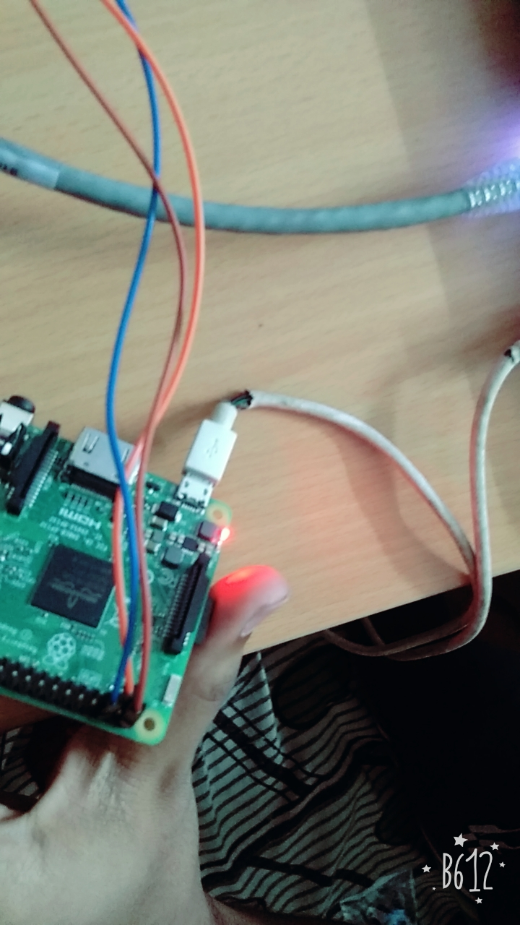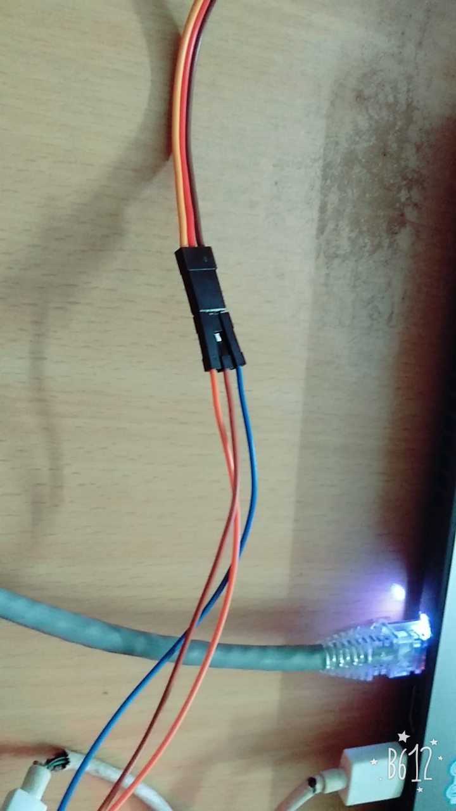

Results and Discussions

The final system is a bionic arm offering six degrees of freedom and the ability to be controlled through myoelectric signals. The total design consists of thirty six individual 3D printed components.

The thumb, index and middle fingers each move independently and the ring finger and small

finger move in tandem. The wrist allows for 180 degrees of rotation and the elbow allows for 110 degrees of bending. A user can control the motion of the arm through a set of EMG electrodes placed on their forearm and/or bicep. At this stage two electrodes sets allow for rudimentary control of the arms range of motions. The device is completely portable and has a battery life of more than 3 hours.

All components have been 3D printed in ABS plastic.

The characteristics and build quality of any engineering design greatly affect system performance. A secure, practical and durable prosthesis is incomparable to something of minimal quality. The nature of 3D printing leads to components of minimal quality. Unfortunately the bionic arm prototype is not of high enough quality and development to be used as a prosthesis or benefit amputees at this point in time. To truly be a practical myoelectric prosthesis the quality of this system would need to be improved, specifically:

• The strength and rigidity of the structure would need to be improved through design changes and use of better materials

• Future work designing a socket connection to attach the system to an amputees stump is required.

• System control improvements would be necessary before an amputee could successfully operate the device reliably

• Non-reusable, permanent electrodes would have to be used for the myography sensing

Conclusion and Future Scope

The academic goals of this thesis were initially uncertain and certainly change throughout the course of the year. The initial aim was to develop a low cost 3D printed myoelectric prosthetic arm. The goals and expectations for this thesis have been achieved and it is hoped that the presented body of work allows for several new thesis topics to be researched in the future.

**Overall System Performance-**

The final system provides relatively good performance and characteristics for a prototype 3D printed model. The device is fast and responsive to electro-myography user input but offers limited strength. Over the course of testing the system has proven to be reliable and has required minimal maintenance since being assembled. The biggest downfall of this design is its lack of toughness. Certain regions such as the wrist are at a high risk of breaking if the device is subject to moderate forces. In the real world a practical prosthetic arm must be able to absorb sudden shocks and support heavy loads without failing. Ways to improve the strength and toughness have been discussed in the previous results section.

References

* Codings from- [www.youtube.com](http://www.youtube.com)
* Python coding books are available in library
* Connections from- [www.google.co.in](http://www.google.co.in)
* Google images
* I2C protocol from internet and human resource.